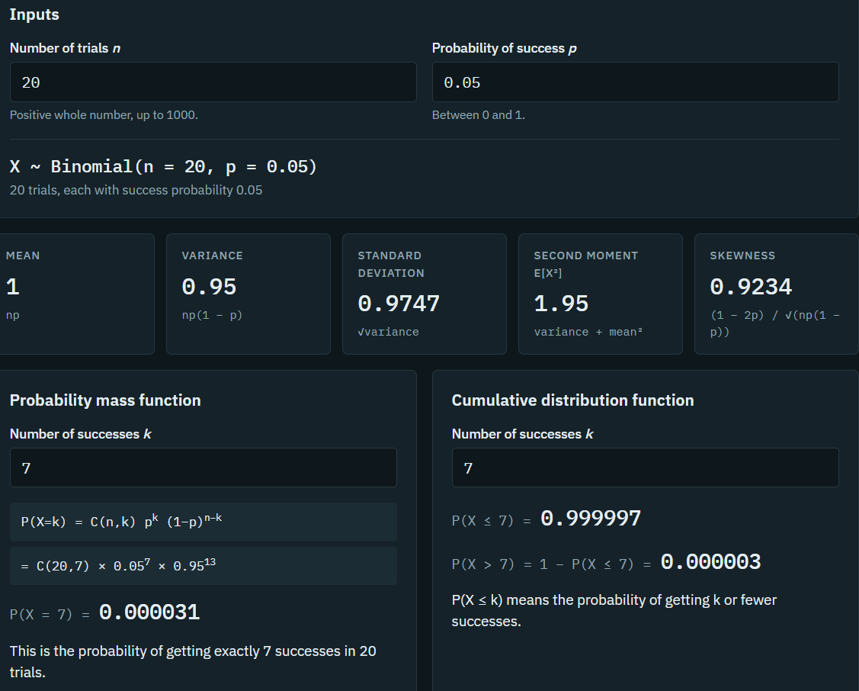

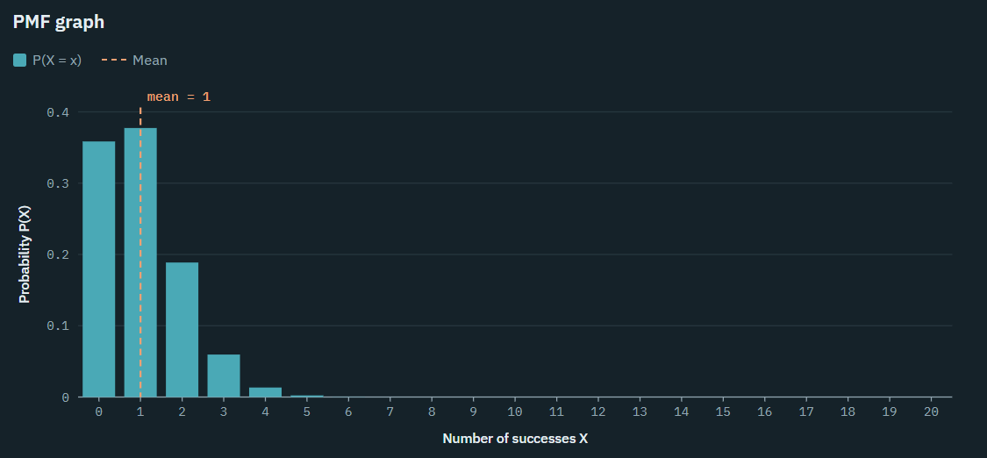

In this session I learned about binomial distribution and how to get mean,variance and standard deviation using python in google colab.In the above graph I took n=20 and p=0.05 and plotted a pmf graph using the inputs .The horizontal line depicts defects and vertical line shows probability count.The graphs shows probability for each successive number showing its variation for the mean value .

